Delinquency:

Next version needs to have an extra section for IND5 (5 rated Business Indirect).

== 2024-08-02

To-Do:

* Add in everything for indirect (brandon will hide)
  + Hide cells if possible
* Other paul formatting items

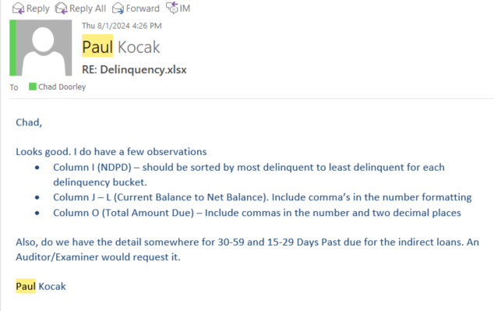

== 2024-08-09

Changes listed below have been fixed.

Currently [0.91]

== 2024-10-07

Inputs from iDashboard

|  |
| --- |
| Product Family |
| Account Number |
| Product Name |
| Customer Name |
| Responsibility Officer |
| YTD Over 30 |
| YTD Over 60 |
| YTD Over 90 |
| YTD Over 120 |
| NDPD |
| Current Balance |
| Charged Off |
| Net Balance |
| Risk |
| Non Accrual |
| Total Amount Due |
| Next Payment Due Date |
| Major |

Major is appended by me in the preprocessing workflow

== 2024-10-09

|  |  |  |  |  |
| --- | --- | --- | --- | --- |
| True | Product Family | V_String | 255 |  |
| True | Account Number | V_String | 255 |  |
| True | Product Name | V_String | 255 |  |
| True | Customer Name | V_String | 255 |  |
| True | Responsibility Officer | V_String | 255 |  |
| True | YTD Over 30 | Double | 8 |  |
| True | YTD Over 60 | Double | 8 |  |
| True | YTD Over 90 | Double | 8 |  |
| True | YTD Over 120 | Double | 8 Reference alerts to find these statistic codes |  |
| True | NDPD | Double | 8 |  |
| True | Current Balance | Double | 8 |  |
| True | Charged Off | Double | 8 |  |
| True | Net Balance | Double | 8 |  |
| True | Risk | V_String | 255 |  |
| True | Non Accrual | V_String | 255 |  |
| True | Total Amount Due | Double | 8 |  |
| True | Next Payment Due Date | Date | 10 |  |
| True | MJACCTTYPCD | String | 4 | Major |

Spent several hours thinking about this and working with Paul K/ Brandon George.

Warehouse table (WH_ACCTLOAN_ME) is giving a different answer vs the iDashboard report that comes out on the first of the month (same EFFDATE of 09/30/24)

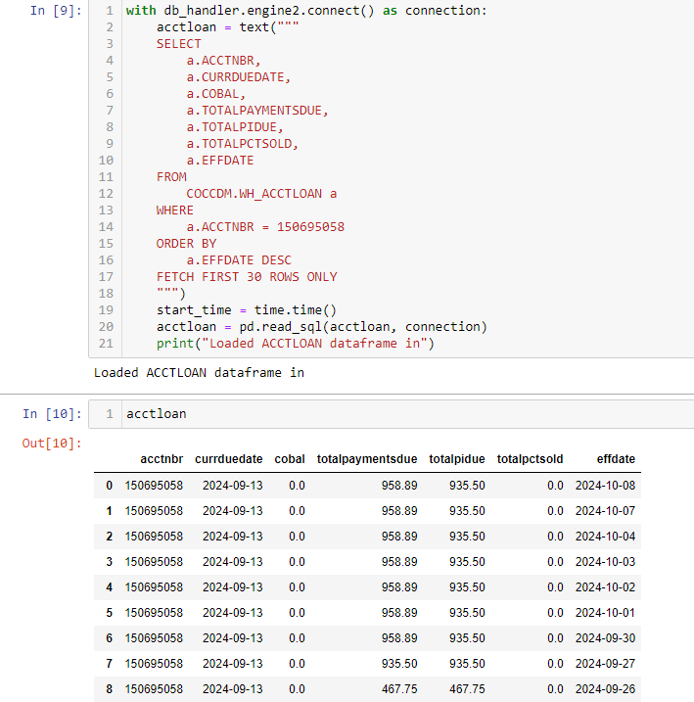

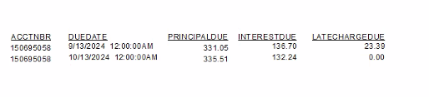

Ok, got it. Thanks to Tom K who had encountered this before.

Only focused on payments that are "past due" not total payments due at specific points in time.

== 2024-10-16

Delinquency is possible. Using month end tables for everything and a current (last business day table) and this will be a matching system.

== 2024-10-17

Focused effort on building delinquency from scratch with improved data model, better validation through pydantic, and automated distribution to loan review mailbox

This is the table needed to get the past due payments total (dropping off ones that have been billed but are within 15 day grace period).

Formula = (Due Date + 15 days) <= RUNDATE

Will need to be run on the first of the month because there is no historical data capture of rundate.

Will run TTLPMTDUE table again on the 5th of the month (or whenever) and update “CURRENT, PAID MM/DD” for any where there is no more past due balance.

Validation against iDashboard

Same loan

Must be a timing issue.

This stallion concrete is showing 958.08 + 938.08 even though one of the payments isn’t past due. I think there is a misunderstanding of how the current one works.

The way this should function is only showing past due payments. If they pay the past due payment, they are “paid current.” Current one will still show them with a total due (which is next payment)

Post-pydantic validation:

Recoded entire thing today. Delinquency is in a good spot. Now has validation steps and pulls entirely from COCC.

Further work:

* Figure out how to automate the paid currents -> goes in the comment column.

== 2024-10-30

Looking at this today. Copying it into my month_end execution loop

Want to point out that we have the same field on Delinquency/NonAccrual that actually show a different amount (delinquency uses the past due total and nonaccrual uses totalpaymentsdue from the WH_ACCTLOAN table). Important to note. The delinquency method uses TOTALPAYMENTS table and calculates in a specific way, excluding upcoming payments that aren’t delinquent yet



Good example

Delinquency Total Amount Due:



NonAccrual Total Amount Due



== 2024-11-04

“””

Chad,

I was just looking at your Delinquency report and you have the Indirect Business loans showing up in the Commercial section. Those should be removed. Also there is no count column for each group. There is a new loan showing up for the Residential Mortgage section call BCSB Down Payment Assistance. Not sure that is supposed to be there. I have a call into Chris Alves.

Thanks.

Brandon

“””

Delinquency fixes:

* Refer to brandon's email
* Sort two way - DPD and alphabetically name
* Gotta get it on month end data again instead of live database
  + Fixed all this

Got the paid current working I believe, loan review and collections are going to cross validate.

== 2024-11-05

Had to fix the fact that ‘TMLP Saves Loan ‘ has a space in the product name. I was hard coding a list of acceptable product names for consumer loans and these weren’t showing up. This has been resolved.